Business Requirement Document
Project Name: MOU Client on Android
Project FP Code: FP/PRJ
Project Owner: Pankaj Choudhary
BRD Version No: 0.3

Table of Contents
1. Executive Summary 4
2. Acronyms /Abbreviations 5
3. Scope 5
3.1. Included in Scope 5
3.2. Excluded from Scope 5
4. Business Overview 5
4.1. AS IS 5
4.2. TO BE 5
5. Stakeholders 6
6. Requirement Summary 6
7. Requirements Details 7
7.1. Client registration 7
7.1.1. Business Process Description 7
7.1.2. Business Rules for Requirements 1 7
7.1.3. Assumption for requirement 1 7
7.2. Facilitating Operator On-boarding 7
7.2.1. Business Process Description 7
7.2.2. Business Rules for Requirements 2 8
7.2.3. Assumption for requirement 2 8
7.3. Operator Login 8
7.3.1. Business Process Description 8
7.3.2. Business Rules for Requirements 3 8
7.3.3. Assumption for requirement 3 8
7.4. Mobile Number/email Update 9
7.4.1. Business Process Description 9
7.4.2. Business Rules for Requirements 4 10
7.4.3. Assumptions for Requirements 4 11
7.5. Successful Mobile Update EID List 11
7.5.1. Business Process Description 11
7.5.2. Business Rules for Requirements 5 11
7.5.3. Assumption for requirement 5 11
7.6. Payment Authorization Code (PAC validation) Hook - Integration of MOU Client with Registrar API 12
7.6.1. Business Process Description 13
7.6.2. Business Rules for Requirements 6 15
7.6.3. Assumption for requirement 6 15
7.7. Operator Sync 16
7.7.1. Business Process Description 16
7.7.2. Business Rules for Requirements 7 17
7.7.3. Assumption for requirement 7 17
1. Security Requirements 18
1.1. CIA – Rating for the applications 18
2. Fraud Risk Requirements 18
3. Other Information 18
4. Sign off sheet 20
Revision History 21

Executive Summary

The Unique Identification Authority of India (UIDAI) provides a Unique Identity (Aadhaar) to all Indian residents. The UIDAI proposes to provide online authentication using demographic and biometric data.

For mobiles to be instruments of authentication for digital identity, mobile number should be unique, authenticable and fulfill requirements of non-repudiation. A possible way of achieving the same would be to link the mobile numbers of users to their Aadhaar and use Aadhaar OTP as one of the user authentication scheme. Aadhaar system already offers a mechanism to keep mobile number linked to Aadhaar identity and use it via mobile OTP (One Time Pin) based authentication.
Use of Aadhaar linked mobile OTP authentication allows the following:

- Enable remote and secure verification of an Aadhaar holder using mobile during mobile based services.
- Enable use of mobiles as an identity instrument and trusted authentication factor that is attached to Aadhaar, thereby simplifying online access to public services.

In addition, registered mobile numbers are used for resident communication, providing UIDAI mobile application for features such as HOTP, biometric locking, etc.
Such large scale usage assumes that mobile number in Aadhaar database is up to date. In addition to currently existing update mechanisms (permanent update centers, self-service update portal, etc.), if UIDAI offers a mobile update API for “trusted” authentication user agencies (such as specific Government AUAs, banks, etc.), few lakhs of biometric update touch points can be made available to residents for easy linking and updating of their mobile number within Aadhaar system.

This document is the proposed use Mobile Update API for use within trusted Enrollment Operators. A new mobile update Android client will be developed where the mobile update API will be integrated and a new operator type “MOU Operator “will be introduced .These operator can use the MOU client and can perform the mobile update enrollment’s from the new MOU Client.

Acronyms /Abbreviations

Term | Description
UIDAI | Unique Identity Authority of India
EA | Enrolment Agency
POI/POA/POR | Proof of Identity / Proof of Address/ Proof of relationship
CEL | Child Enrolment Client

Scope

Included in Scope
- MOU Client
- Integrated of MOU API with MOU Android client
- Integration of MOU Client with Registrar –PAC Validation API
- MOU Client –Operator Sync

Excluded from Scope
Section not mentioned in ‘Included in Scope’ is considered Out of Scope.

Business Overview

AS IS

CEL (Child enrolment client), an android tablet based application, allows the child enrolment with few demographic details, biometric authentication and no documents. MOU API is integrated with the CELC client.

TO BE

A new MOU Client needs to be developed and MOU API needs to be integrated with the MOU client.

Stakeholders
- UIDAI
- REG/EA
- MSP

Requirement Summary
Req. No. | Description | Type | RFP coverage | Cost implication
Req01 | Client Registration | New | No | FP
Req02 | Operator On-boarding | New | No | FP
Req03 | Operator Login | New | No | FP
Req04 | Mobile Number/email update | New | No | FP
Req05 | Successful Mobile Update EID list | New | No | FP
Req06 | Payment Authorization Code (PAC validation) Hook - Integration of MOU Client with Registrar API | New | No | FP
Req07 | Operator Sync | New | No | FP

Requirements Details

Client registration

Business Process Description

The enrolment to start at the center, the client needs to be registered with the server. The details to be sent at the time of registration include Registrar ID, Enrolment Agency ID, Station ID, location Code and Operator Administrator credentials. There will be Reset and Register button which will be used to reset the data in the text boxes and register the client respectively.

Business Rules for Requirements 1

- Using the internet facility, the client will be registered once and will remain registered until it deregistered using deregistration button.

- Whenever the operator clicks on the Deregistration button, the client will be deregistered and any mobile update activity will not be performed from the client.

Assumption for requirement 1

Client registration need to be done online as it is an online version of CEL.

Facilitating Operator On-boarding

Business Process Description

To onboard the Operator on the client, the operator has to be formally added to the client by providing operator details, viz., Operator ID, Operator Name, Operator Aadhaar and biometric authentication. Once the authentication is successfully completed, the client will display the name of the operators. There will be a reset button to reset the text entered in the text boxes while Add Operator will be there to add the operators. The Operator should be active on server and the status of Aadhaar should be valid for successful biometric authentication.

Business Rules for Requirements 2

- The operator has to authorize using the biometric device attached to the device which authenticates the operator instantly.
- Also before every mobile update, operator has to provide his authentication. In case the operator authentication fails then the operator has to update his biometric from the standard client to work on enrolment.
- The operator type should be of MOU Operator.

Assumption for requirement 2

- The operator should be having valid Aadhaar so that biometric can be authenticated successfully.

Operator Login

Business Process Description

The operator needs to provide the Aadhaar and biometric authentication for successful login. On successful authentication, the operator is logged in to the client. All the mobile update packets will have the Operator ID in the packet.

Business Rules for Requirements 3

- The form will display two fields, viz., Operator’s Aadhaar Number and Biometric Authentication. The authentication from the client will be single finger authentication.

Assumption for requirement 3

- The operator needs to be registered on the portal as well as should be having UID for authentication.

Mobile Number/email Update

Client will allow residents to update their new mobile number or modify their old mobile number. Once the request for modification of the number will be raised then the same mobile number needs to be authenticated via OTP Authentication and the biometric of the enrollment operator and the resident. Application will consume Mobile Update API which will captures Aadhaar number, consent, new mobile number, verification code, and biometrics of the resident. In addition, optional attributes email ID and data sharing consent can also be captured and updated.

Business Process Description

In order to update the new number the enrollment officer/operator will go to the Mobile Update link and the below fields needs to be updated in order to update the mobile number.
- New Mobile Number
- Generate OTP
On Generate OTP button validate:-
New mobile number should be of “10 digits “and “non-empty”. If the condition does not meet then CELC should pop up a message as “Enter Correct Mobile Number”.
Post providing the correct details an OTP will be generated and will be send to the new mobile number via SMS and a new screen will open in order to authenticate the OTP.
On the new page below flags need to be checked in order to authenticate and update new mobile number.
- Resident Aadhaar Number (mandatory)
- Resident Biometric (mandatory)
- Operator Aadhaar Number (read only mode ,same as provided at the LOGIN screen)
- Operator Biometric (mandatory)
- Data Sharing Consent
- Resident Disclosure(mandatory)
- OTP(mandatory)
- Email (non-mandatory)
- New mobile (read only mode, provided at the Generate OTP screen)
- Update Mobile
Resident will provide his biometric and the received OTP on his mobile number, operator will provide his biometric and a MOU request will be made from the client to MOU server.
After successful Authentication the MOU request which included authentication both operator and resident, update packet will be created and EID will be sent to the MOU server to MOU client.

Business Rules for Requirements 4

- Unique OTP will be generated for each transaction.
- Mobile Number should be of 10 digits and Aadhaar number should be of 12 digits.
- Resident Aadhaar Number should be of “12 digits" and “non-empty”. If the condition does not meet then client should POP up a message as “Enter Correct Aadhaar Details”.
- Text for disclosure :-
‘Disclosure under section 3(2) of THE AADHAAR (TARGETED DELIVERY OF FINANCIAL AND OTHER SUBSIDIES, BENEFITS AND SERVICES) ACT, 2016:
I confirm that I have been residing in India for at least 182 days in the preceding 12 months & information (including biometrics) provided by me to the UIDAI is my own and is true, correct and accurate. I am aware that my information including biometrics will be used for update of Aadhaar and authentication. I understand that my identity information (except core biometric) may be provided to an agency only with my consent during authentication or as per the provisions of the Aadhaar Act. I have a right to access my identity information (except core biometrics) following the procedure laid down by UIDAI.’
- After capturing resident and operator finger detail a MOU update request will be made from the client to MOU server. After successful Authentication the MOU request which included authentication both operator and resident, update packet will be created and EID will be sent to the MOU server to MOU client.
- For each MOU request operator authentication is mandatory.
- New Mobile number on update mobile screen should be non-editable or in read-only mode. Mobile number should be same as provided in the Generate OTP screen.
- For each MOU request operator authentication is mandatory.
- For successful MOU update request from the client to MOU API actor needs to mandatorily accept the resident disclosure or resident needs to mandatorily accept the disclosure .If resident did not accept the disclosure mobile update request should not happen.

Assumptions for Requirements 4

- Auth Generic OTP will be used to send the OTP.
- Only resident can update their mobile number/email ID from this application, child cannot use this application to update his mobile number and email ID.

Successful Mobile Update EID List

Operator can see the successful mobile update enrollment IDs using this tab. The report will show the top 1000 (according to latest response time) successful enrollment ID for mobile/email update done from the client/device.
Column Name:-
EID, Creation Time (Successful response time)

Business Process Description

- Operator will click on the MOU list tab on the CLEC dashboard.
- The report will show the last 1000 successful EID, Creation Time (Successful response time)

Business Rules for Requirements 5

- Historical data will be maintained in local client /device DB
- Only successful EID will be displayed.

Assumption for requirement 5

Payment Authorization Code (PAC validation) Hook - Integration of MOU Client with Registrar API

It is expected that, some backend (payment portal in the case) like CSC would provide complete payment flow, operator management, cash collection, reporting, etc. without involvement of UIDAI. Once the payment is made for a mobile/email update, the registrar/CSC system backend or payment portal should issue a usable "payment authorization code - PAC" (it can be shown on the screen and/or send to operator mobile, etc.)
Client shall allow operator to type in the PAC before mobile update request. UIDAI client will do an HTTPS call to configured URL (this SHOULD NOT be editable by EA/REG/Operator) to validate the PAC. URL should be configurable at the backend at registrar/EA level which is downloaded as part of client configuration (non-modifiable). If "payment required" flag is enabled, client should mandate the operator to type in the PAC without which mobile update will not be completed. The registrar backend will validate PAC and return success/failure to back to client. If it is valid, Client would proceed to save the mobile update and complete mobile update flow. Otherwise, a valid PAC will have to be retyped. Operator can also "cancel" the mobile/email update request altogether and start again.
Changes in client:
Client configuration to have the following configuration entries (all non-modifiable by EA/REG/Operator):
- "Payment-api-url=https://paymentportal/validatePAC",
- "Payment-service-api-key=",
- “PAYMENT_REQUIRED=TRUE/FALSE"
Based on the flag settings and update parameter value, client shall pop up the payment confirmation dialog (it should have a message, a text box for PAC entry, OK/Cancel button) before making and update request.

On OK button, validate PAC to be "non-empty" and call the payment API URL and pass input:-
- Organization: - UIDAI
- API Token
- Client Name: - MOU Client
- Client Version
- Registrar-code
- EA-code
- Operator-id
Transaction Info:-
- Tx ID (Unique)
- Service-type: MOBILE-EMAIL-UPDATE
- PAC
Backend API should return the following:-
- Return value: - “SUCCESS | FAILURE"
- Tx id
- Error-message
If success, proceed. Else show error message to operator and pop-up PAC dialog again. Of course, operator can click "cancel" button on the dialog and cancel the whole update flow if they wish.

Business Process Description

- Client shall allow operator to type in the PAC before update confirmation, this option will only come if client is configured with payment required flag YES.
- Based on the flag settings and PAYMENT_REQUIRED parameter value (True/false), client shall pop up the payment confirmation dialog (it should have a sentence, a text box for PAC entry, OK/Cancel button) before confirming mobile update request.
- Operator will type the PAC in the textbox and will click on OK.
- Client will call the Registrar API URL (API URL is already configured in the client) and will pass the following parameters :- Organization, API Token ,Client Name ,Client version ,Registrar Code ,EA code ,Operator ID ,Tx ID, Service Type ,PAC.
- Registrar API will validate the request and will return the following parameters:-Success/Failure, Tx ID, and Error Message (in case of failure).
- If success, proceed. Else show error message to operator and pop-up PAC dialog again. Of course, operator can click "cancel" button on the dialog and cancel the whole update flow if they wish.
- If PAC is validated the client will prepare a mobile update request to MOU API and if the MOU server authenticate the MOU request the server will send the EID to the MOU client of that MOU update request.
- This EID will be pushed from the client to Registrar API
Transaction Info:-
- Tx ID
- PAC
- EID
Backend API should return the following:-
- Return value: - “SUCCESS | FAILURE" (EID is SYNC in the Registrar system or not)
- Tx id
- EID
- Error-message

Business Rules for Requirements 6

- Unique transaction id (PAC) for each transaction will be generated by Registrar.
- UIDAI client will do an HTTPS call to configured URL (this SHOULD NOT be editable by EA) to validate the PAC. URL should be configurable at the backend at registrar/EA level which is downloaded as part of client configuration (non-modifiable). If "payment required" flag is enabled, client should mandate the operator to type in the PAC without which mobile/email update would not be completed.
- Registrar server can send only 2 response either SUCCESS | FAILURE, whatever text server will send as a response it will be displayed in the client.

Assumption for requirement 6

- Handling of scenarios where the PAC was approved but the update was rejected during the update processing will not be in scope for client and should be handled at the registrar API layer.
- The PAC will be validated in Registrar service and can be used multiple times as well. No control of validation of PAC will be done at the client. Only validation of PAC filed in the client is that Maximum length of PAC will be 25 and can be of alphanumeric type.
- Mobile Update of resident will be dependent on Registrar API return message, on successful response, UIDAI will go ahead and process the update. On Failure response, UIDAI will not update the data and will show an error message about invalid PAC entered in the system. Client application would not have any control of the Registrar API responses.
- The scenario of PAC is approved at Client and later on packet got rejected would be out of scope for MSP perspective and should be handled by the Registrar.
- Registrar site already has SSL domain certificate deployed. It is a server side certificate and nothing is needed on the client side. Client just need to make https call to Registrar server. So no security certificates required.
- There is no restriction on the retry‘s number i.e. number of times operator can re-try in in case of failed transactions.

Operator Sync

At present every enrolment client is required to sync at least once in 10 days. So on similar bases in order to also control the operator, it is proposed to add operator sync system. In this system it will be required by operator to perform biometric authentication and Aadhaar OTP at least once in 10 days on the client in which he is on boarded. The on boarded operators who do not do operator sync within 10 days, they cannot perform the mobile update from that Client. This will also ensure that mobile number of operator is in operation & working.
It is proposed to make update of mobile update centers locations and operator’s details so during the operator sync i.e. operator’s Authentication (Biometric + OTP) on the same screen operator will sync the center and operator’s details at server end. So for this sync some additional parameters such as name of the center, type of the center (PEC/CAMP), complete address of the center, operator name & his mobile etc. will be taken in the ECMP client. This will ensure that list of enrolment centers are always updated at the server end. This may be implemented in all types of clients in future. Current scope is only at ECMP.

Business Process Description

- A new configurable parameter will be added called as “No. of days for operator sync”
- Operator Authentication will be done, a new operator sync screen will be prepared where operator will authenticate himself.
- Biometric Authentication and mobile based OTP Authentication will be done.
- From the operator’s Aadhaar number, his mobile number will be fetched and OTP will be send to that mobile and accordingly OTP will be validated. Operator’s Aadhaar number will only be a read only field.
- Centre and operators details will also be synced at server end ,the configurable parameter will be same for Operators Authentication and center/Operator’s details sync and will be called as “No. of days of operator sync”
- For Centre details Sync will be done, same operator’s sync screen will be prepared where all below details will be shown :-
- Registrar (Automatic Populated, non-modifiable),
- EA (Automatic Populated, non-modifiable)
- Station ID (Automatic Populated, non-modifiable)
- Name of center (To be input by operator, modifiable)
- Address of center, (To be input by operator, modifiable)
- Operator name (Automatic Populated, non-modifiable)
- Operator ID (Automatic Populated, non-modifiable)
- Operator Mobile Number (Automatic Populated, non-modifiable)
- Operator Aadhaar Number (Automatic Populated, non-modifiable)
- Type of center (Dropdown values: Permanent /Camp-Mode, to be selected by operator, modifiable)
- Center ID (As of now blank, will be disabled as of now)
- GPS details (Automatic Populated, non-modifiable, in few cases it will be blank)
- Whitelisted for BE (True/False)
- Operator will click Sync button and all the details will be stored at the sever end.

Business Rules for Requirements 7

- A new configurable parameter will be added called as “No. of days for operator sync”
- OTP will be send to only registered mobile number against Aadhaar number, no input of mobile number should be allowed for OTP validation by the operator. Mobile number and operator’s Aadhaar number will be a read only field.
- If operator do not perform the operator sync, after the sync date no enrollments should be allowed from that ECMP machine.
- Sync date will be a configurable parameter.
- If operator do not perform the center and operators details sync, after the sync date no mobile update should be allowed from that client.
- Operator Authentication and center/operators details sync screen will be same, both sync will be performed simultaneously and both have same one configurable parameter called as “No. of days for operator sync”

Assumption for requirement 7

- The operator should have registered his mobile number with his Aadhaar for OTP Auth.

Security Requirements
- Necessary for the application/ database and identify the key parameters to be logged and audited.
- Public/ Private Key Infrastructure: If PKI will be used for secure information, protection of encryption/private key, secure distribution of the public key and appropriate encryption algorithm (RSA 2048, AES 256 & SHA 512) must be considered.
- Any Data at rest should be stored in Encrypted form.
- Mapping between Child Aadhaar Number and Parent’s Aadhaar number should be done in backend as to establish trust level and proper authentication.
- Application containing any stored passwords or sensitive data should be encrypted and stored.

CIA – Rating for the applications

Highly Critical: These applications, if compromised can have immediate impact on UIDAI reputation and Operations.

Fraud Risk Requirements
N/A

Other Information
Client Registration API - Once the client is installed / or decommissioned (all data and setting will be erased) the client will open the registration screen with the following fields:
- Registrar ID
- Enrolment Agency Code
- Station ID (5 digit station code)
- Admin portal user name
- Admin portal password

Client will post an encrypted XML request to the server to register itself as well as proceed with operator on boarding and child enrolment.

Operator Authorization - the operator will enter his Aadhaar and provide the biometric details for authentication.

The request will be authentication xml and posted to the CIS server and the server will perform the following checks:
- Authentication result (Yes/No)
- Operator certification (Valid or not )
- Operator active status (in case Blacklisted or Inactive )

Once all the conditions are met, client response will be used to onboard and make the operator authorized to do enrolments on the client.

Operator Login - After the client is started to open the enrolment screen the client will ask the operator to authenticate him/her before each enrolment.

The server response will contain the authentication status as well as provide server date and time. The server date will be used to calculate the age check on the client and ensure children below 5 yrs are enrolled.

Enrolment API - After successful login at point , the client will open the enrolment screen and the operator will take the photograph, and enter the name, gender and dob of the child, then capture the mother's Aadhaar, father's Aadhaar and as per the availability of the parent capture the biometric and make an authentication call, if the authentication is successful, it will proceed to the review screen and ask for the operator's biometric who has logged on to the client once again the operator will provide the biometrics and upon successful authentication, the xml file will be created, digitally signed, stored locally and an attempt will made on the background to post it to the server.

API Calls - Authentication

    - One of the parent, preferably mother’s biometric will be captured and an authentication xml will be formed and posted to the server,
    - Operator biometric will be captured and an authentication xml will be formed and posted to the server.

In both the authentication calls the server response will contain auth result as well as the transaction reference.
Screenshots
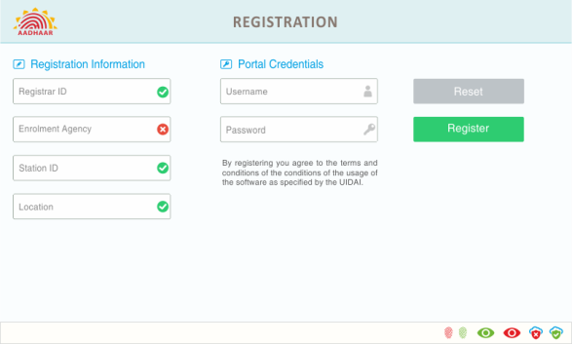
Fig 1.0: Client registration
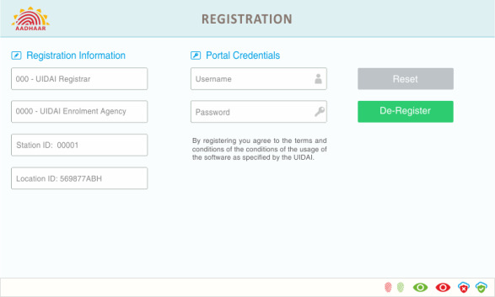
Fig 2.0: Client de-registration

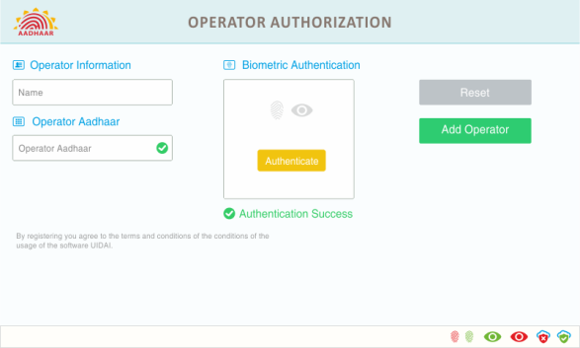
Fig 3.0: Operator on-boarding

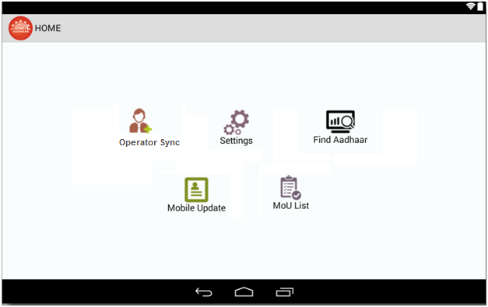
Fig 4.0: Mobile Update Link

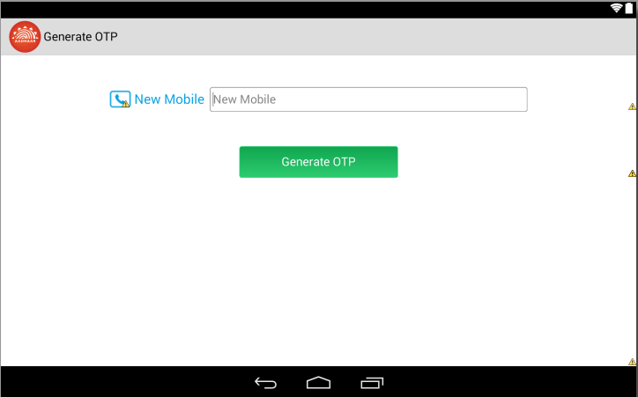
Fig 5.0 Generate OTP Screen

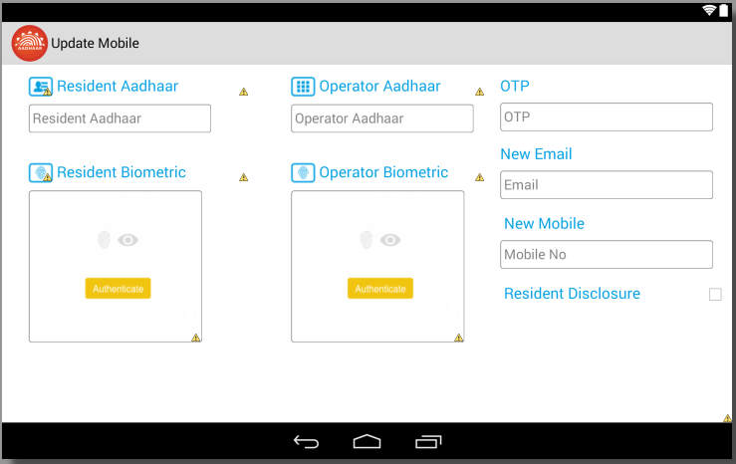
Fig 6.0 Mobile Update Screen

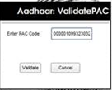
Fig 7.0 Payment confirmation dialog Pop-Up

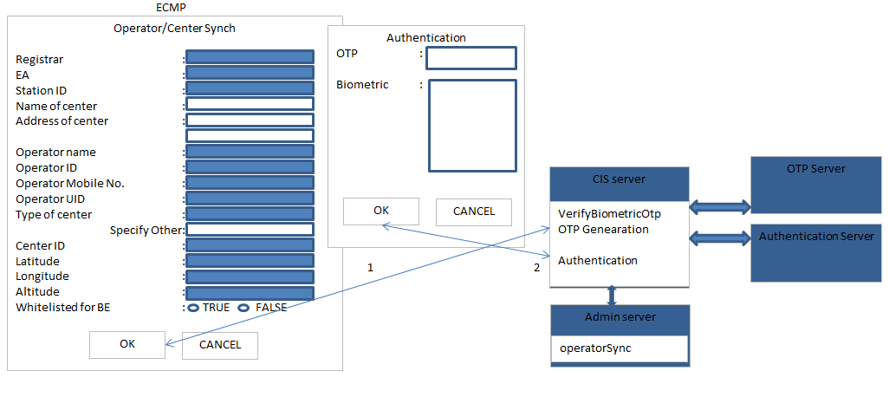
Fig 8.0 Operator Sync

Sign off sheet

The following parties have been identified as key project stakeholders. Please read the following statement and confirm your acceptance of the business requirements as described in this document.
I have read the Business requirements presented in this document and approve the requirements as being complete for the business needs of the request. My signature below indicates my Commitment and support for the project.

UIDAI / MSP Approvers
Name | Signature | Date

Revision History

Version no. | Date | Author | Description/summary of changes | Reviewed by | Approved by (MSP) | Approved by (UIDAI)
0.1 | 04/19/2017 | Neerav Sachdeva | Initial Draft
0.2 | 04/20/2017 | Neerav Sachdeva | Second Draft, Incorporated Comments given by Pankaj
0.3 | 04/27/2017 | Purav Riat | Included screenshots | Neerav

